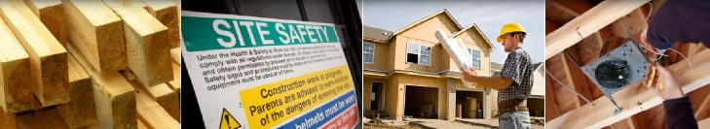
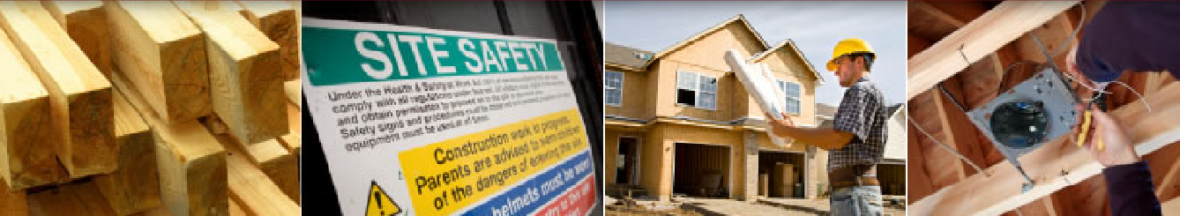

May 27, 2020
Dear Safety Group Member,
COVID-19 CLAIMS:
Here are some guidelines to follow should you encounter any questions or requests for claim filing.
Coronavirus (COVID-19)

My employee has been diagnosed with COVID-19. Is that covered under Workers’ Compensation Insurance?
No, not for employees working in construction. Some states have enacted legislation, which basically rules that all COVID-19 exposure is related to their work activity. This is not true for New York State. New York State feels that the current laws are sufficient to determine whether a case is causally related to work. All New York State workers who are affected by COVID-19 would qualify for benefits with either disability insurance, unemployment insurance, or workers’ compensation insurance.

What type of work places would workers’ compensation claims cover for COVID-19 claims?
Working with sick people needs to be endemic to the workplace – that is, working with sick people needs to be a normal, everyday activity at the workplace. Occasional contact with people, who may be sick, such as a delivery driver, would not be included with this.
The workplaces that fall into this category would be: (1) designated as an essential business by New York State, and (2) have a customer-facing role.

Do my employees have any protections if they are afflicted by COVID-19 or if they lose work due to business closures due to COVID-19?
Yes, employees who have missed work due to COVID-19 are encouraged to file a claim through disability or unemployment insurance, depending on their situation.
If an employee becomes sick with COVID-19 then a claim could be filed with disability insurance.
If an employee is laid off due to COVID-19 then the employee would be eligible for unemployment insurance. Also, the federal CARES Act was enacted to supplement unemployment insurance to offer larger benefits for workers unemployed due to COVID-19.

What is the CARES Act?
The CARES Act stands for “Coronavirus Aid, Relief, and Economic Security Act.” It was designed for people affected by COVID-19 but help would not be covered under other means like workers signed into law on March 27, 2020 which applies additional unemployment insurance to workers’ compensation.
These documents provide a very extensive outline about what the CARES Act is, how to apply, and many frequently asked questions:
https://labor.ny.gov/ui/pdfs/ui-covid-faq.pdf
https://labor.ny.gov/ui/pdfs/cares-act-need-to-know.pdf

My employee is aware of unemployment insurance and disability insurance but still wants to file a workers’ compensation claim. What should I do?
The claim will almost certainly be disputed by the insurance carrier; however, we cannot ignore their request to file a claim. Remind the employee that to have a claim they need the following: a positive diagnosis of COVID-19, doctor appointments for COVID-19, and lost time from work. If they still want to file a claim then we recommend supplying them with a claimant packet found here: http://www.wcb.ny.gov/content/main/TheBoard/ClaimantInformationPacket.pdf

What should I do if a Workers’ Compensation claim is going to be filed?
Like mentioned earlier, the claim will be disputed. Some information can be gathered to strengthen the dispute in case the laws are made more lenient in the future. Attempt to gather this information from the employee:
- Did they receive a positive test for COVID-19? When?
- When did they start experiencing symptoms?
- Why does he or she feel the COVID-19 is work related?
- When and where does he or she believe she was exposed to COVID-19?
- How does the employee travel to work?
- What have they done outside their home or work?
- Who do they live with? What are their jobs? Have they been tested for COVID-19? Have they experienced any symptoms? When did they begin experiencing symptoms?

Contact Hamond Safety Management to file a first report of injury form. We will work with the insurance carrier to begin the claim dispute process.

An employee is being laid off due to a work stoppage or a shortage of work due to COVID-19; is this a Workers’ Compensation claim? What should I do?
This is not covered by workers’ compensation. Refer the employee to the unemployment office. Instructions on filing an unemployment insurance claim can be found here: https://dol.ny.gov/unemployment/file-your-first-claim-benefits

An employee caught COVID-19 from their coworker; is this a Workers’ Compensation claim?
Not in the construction industry. The employee should file a DB-450 claim: http://www.wcb.ny.gov/content/main/forms/db450.pdf
For workers in the healthcare industry, for example, the claim being considered work-related would depend on their job duties, contact with people infected with COVID-19, date of contracture, how they travel to and from work, if family members with COVID-19, etc. An investigation needs to be performed.

An employee was diagnosed with COVID-19 and he subsequently infected a family member. Is this a workers’ compensation claim? What should I do?
This is not a workers’ compensation claim. If the employee is caring for their sick family member then they can apply for Paid Family Leave. The employee should file a PFL-1 form: https://paidfamilyleave.ny.gov/pfl-family-care-leave-form

An employee was placed into quarantine; is this a workers’ compensation claim? What should I do?
This is not a workers’ compensation claim. Refer the employee to the disability office or refer them to file for a paid family leave for themselves
The employee could file a DB-450 claim:
http://www.wcb.ny.gov/content/main/forms/db450.pdf
Or – the employee could file for Paid Family Leave for themselves due to self-quarantine: https://paidfamilyleave.ny.gov/if-you-are-quarantined-yourself

What should I do if I think I have COVID-19?
Contact your primary care physician. Do not go directly to the hospital. The CDC recommends a 15-day isolation to prevent the further spread of COVID-19.

If you are concerned that you may have been infected by COVID-19, please contact the NY State COVID-19 Hotline at (888) 364-3065.

